Grace Church, and separately Dr. Dahan Sharef, approached Jean Davison of CompassionMed International in 2012 about a possible CMI mission trip to Sierra Leone during the summer of 2013. The purpose of the trip would be two-fold. First, CMI would assess the possibility of establishing a nursing school under the auspices and direction of Dr Dahan Sharef. The assessment would include physical site visits, establishing local contacts within the local government and local medical establishment and reviewing the necessary startup logistics. In addition, CMI would conduct medical education classes for local nurses at all levels of education with an emphasis on physical assessment skills. The trip was approved by the Board of CMI and was completed between the dates June 1-June 13. Dr. Jean Davison DNP and Dr. Ronald Herring D.O. were the mission members and below is a summary of the mission trip.

General background information on Sierra Leone:
Dr. Sheref is from Sierra Leone and received his medical training in the United States at Duke University. In 1998 he founded Hope Med for the purpose of improving medical care in Africa as a whole and in Sierra Leone in particular. Hope Med is a non-profit organization with a passion for reaching and helping the poor of Sierra Leone attain good health and wellness. The mission is to assist the people of Africa, particularly, Sierra Leone, by (1) identifying communities in need of improved health care and education, (2) cultivating the right relationships for helping us help them, and (3) helping provide the means to meet those needs.
http://hopemed.org/
Presently Hope Med has three medical clinics set up in Sierra Leone serving over 23, 000 people annually and has a nationally recognized college preparatory school of science which was established in 2008. Its aim is “to prepare young men and women for careers in the sciences, medicine, nursing and engineering” http://hopemed.org/programs/grace-school-of-science-gss/. Dr. Sheref shared his vision with me and Dr. Gwen Sherwood, our Associate Dean for Academic Affairs at UNC School of Nursing, of the need in Sierra Leone for establishing a high quality nursing education program.
There is a severe shortage of health workers, especially trained nurses, within Sierra Leone. According to the World Health Organization (WHO) in Sierra Leone the life expectancy of males is 48 years old and for females it is 50 years old with a high infant mortality rate of 165 per 1,000 live births. The health work force is .2 physicians per 10,000 population and 1.7 nurses & midwives per 10,000. The World Health Organization has noted that a shortage of health workers threatens the achievement of the Millennium Development Goals, and WHO encourages global partnership for development (http://www.who.int/topics/millennium_development_goals/en/).

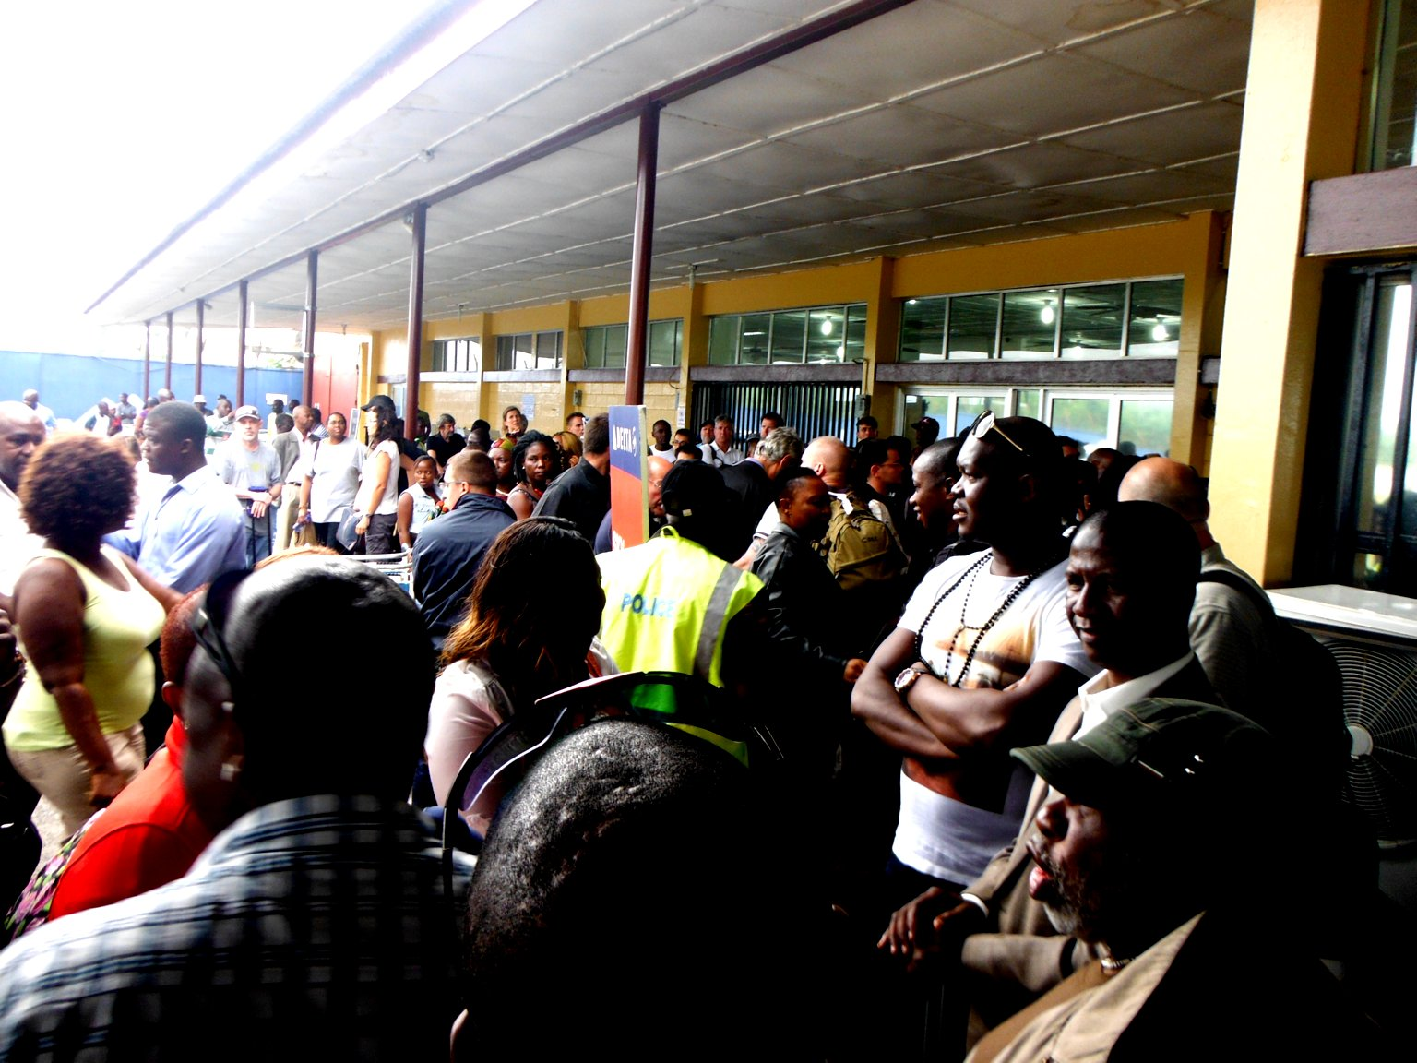

The flight to Sierra Leone from Paris had one stopover in Liberia. When the luggage for the Liberian passengers was being unloaded from the plane it was damaged when a truck backed into a cargo door. We spent 2+ hours on the plane before Air France said the plane could not continue with ANY passengers. So, we had to spend the night in Liberia. After an hour bus ride we arrived at a hotel about 35 miles from the airport. We were brought back the next day around 5PM to catch the flight onto Sierra Leone.
Unfortunately, the plane from Paris had flown in empty and at maximum altitude. As a result, it was very cold and there was a three hour delay until the plane warmed up sufficiently to refuel.
We arrived in Sierra Leone after midnight. Dr Sharef found us and we began our journey into Freetown. The airport is on a peninsula and there is a long ferry ride to Freetown. However, the main ferry doesn’t run after 10PM so we had to utilize a small ‘private’ ferry. The cost was $40/person one way. When we got to the Freetown ‘port’ we could not locate the SUV/driver that Dahan had arranged for the previous day. Dahan negotiated with another driver for a cost of $60. We arrived at Dahan’s apartment 45 minutes later but then couldn’t gain had entry into his condo/apartment. We ended up checking in at 5AM at a portside ‘ hotel’ for $120/ night. We left for Dahan’s apartment again 6 hours later.
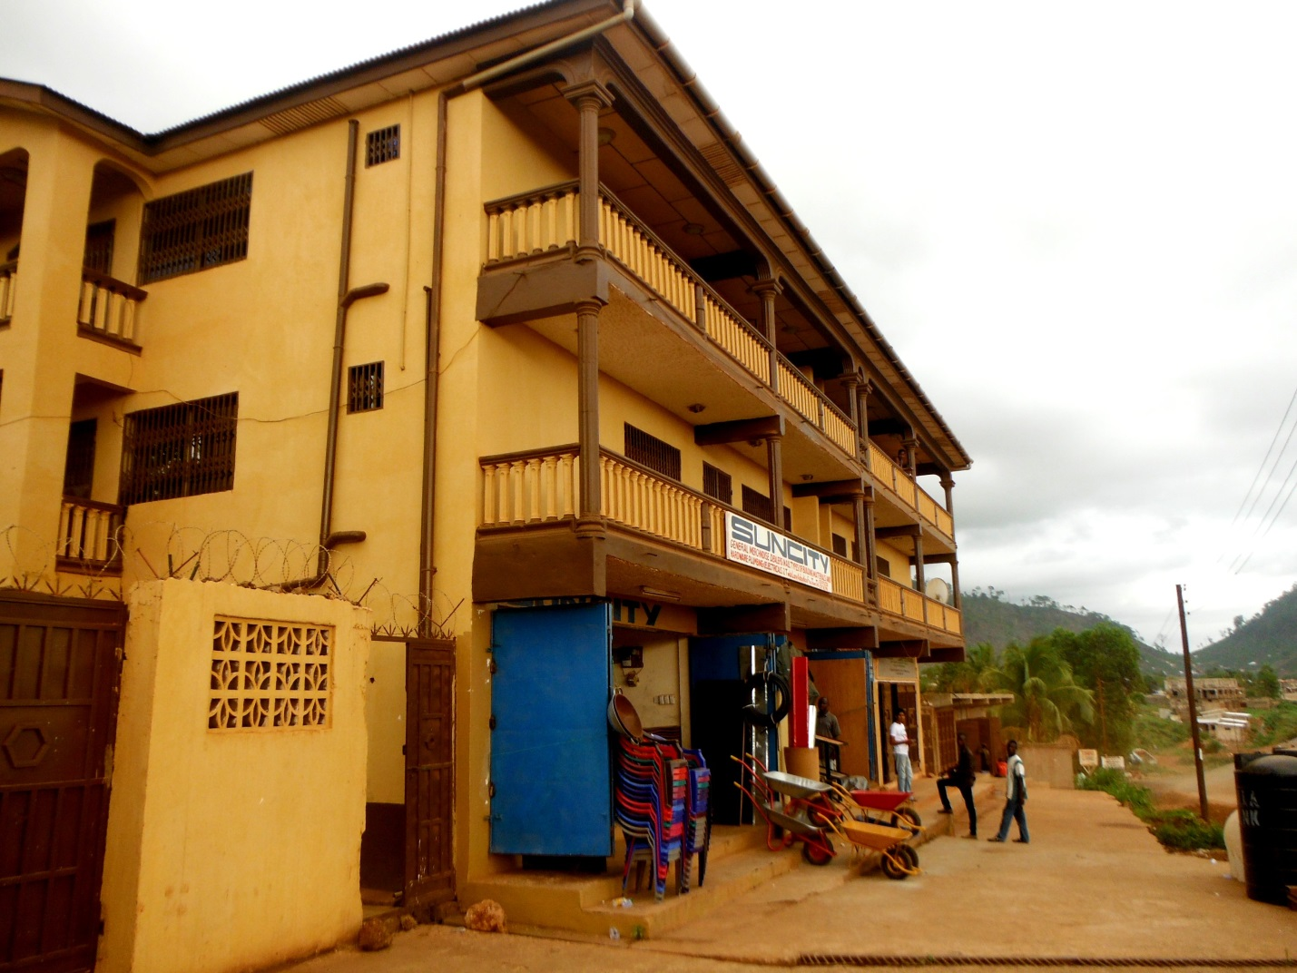
Dahan’s Apt 3rd Floor

The day after arriving we rested and discussed our itinerary. We had hoped that Dahan would have prepared our basic weeklong itinerary prior to our arrival, but his cell phone wasn’t functioning and so that wasn’t possible. As a result, we did not have any appointments or classes scheduled. We were going to have to visit the schools and government offices without prior notice and hope we could arrange our schedule on a day to day basis.
There isn’t electricity at Dahan’s at the moment. The electrical infrastructure is very unreliable. Dahan is paying for electricity but hasn’t had any for weeks. He does have a generator that can power a few lights. With a lack of sufficient power there is no refrigeration or functioning stove. The neighbors cook on the back stairwell with a small charcoal burner. Dahan arranged for food to be prepared by his sister and delivered by taxi. As for our sleeping arrangements, our room ws spacious and we set up a protective bed mosquito net over a 4 poster bed. Dahan had just moved into this apartment a few weeks ago and it is on the South-Western suburb of Freetown. It feels safe and relatively clean compared to Freetown.
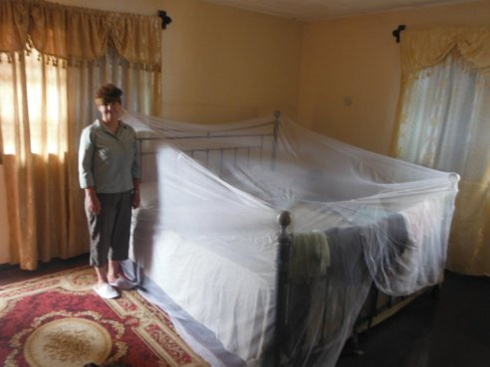

The construction of the building is not very good. There are large gaps around the window frames and doors. As a result, the room has lots of insects flying around. The smell of burning garbage is fairly constant as that is how it is disposed of in the neighborhood. The plastic content of the garbage results in toxic fumes. Lung disease is a serious problem here.

.

We decided to go to the Ministry of Health and try and get a meeting with the Chief Nursing Officer. Dahan does not own a private vehicle so it was necessary to rent a taxi for the day. There is a separate charge for the vehicle, the driver and the fuel. Although Dahan only lives about 6 miles from the center of Freetown, it took almost 1.5 hours to get downtown. There are no functioning traffic lights and it is a chaotic travel situation.
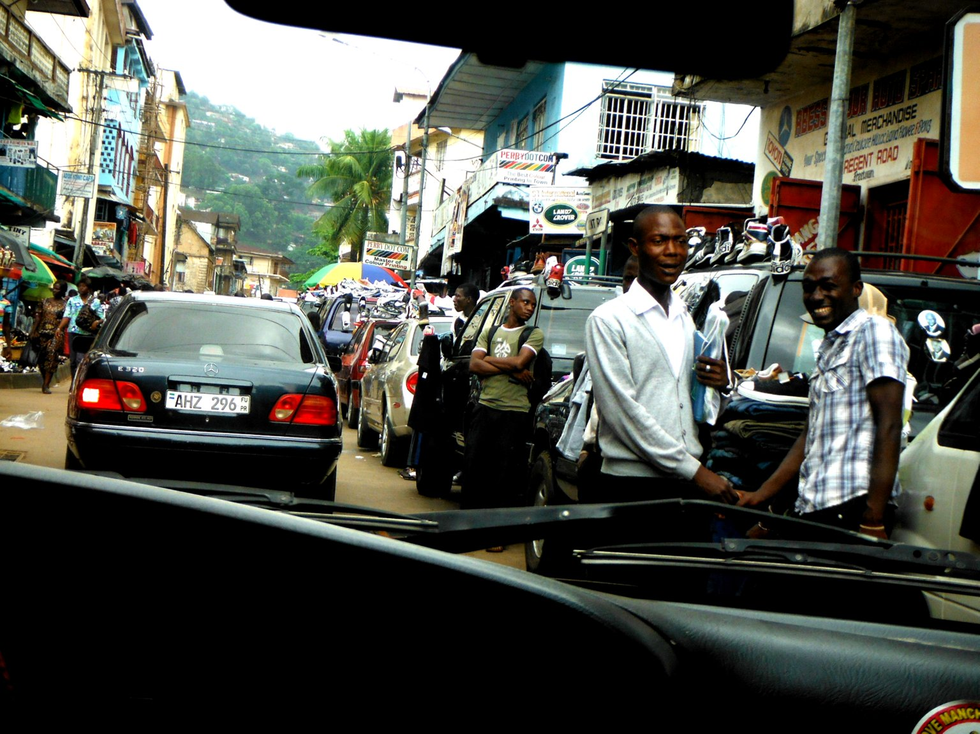

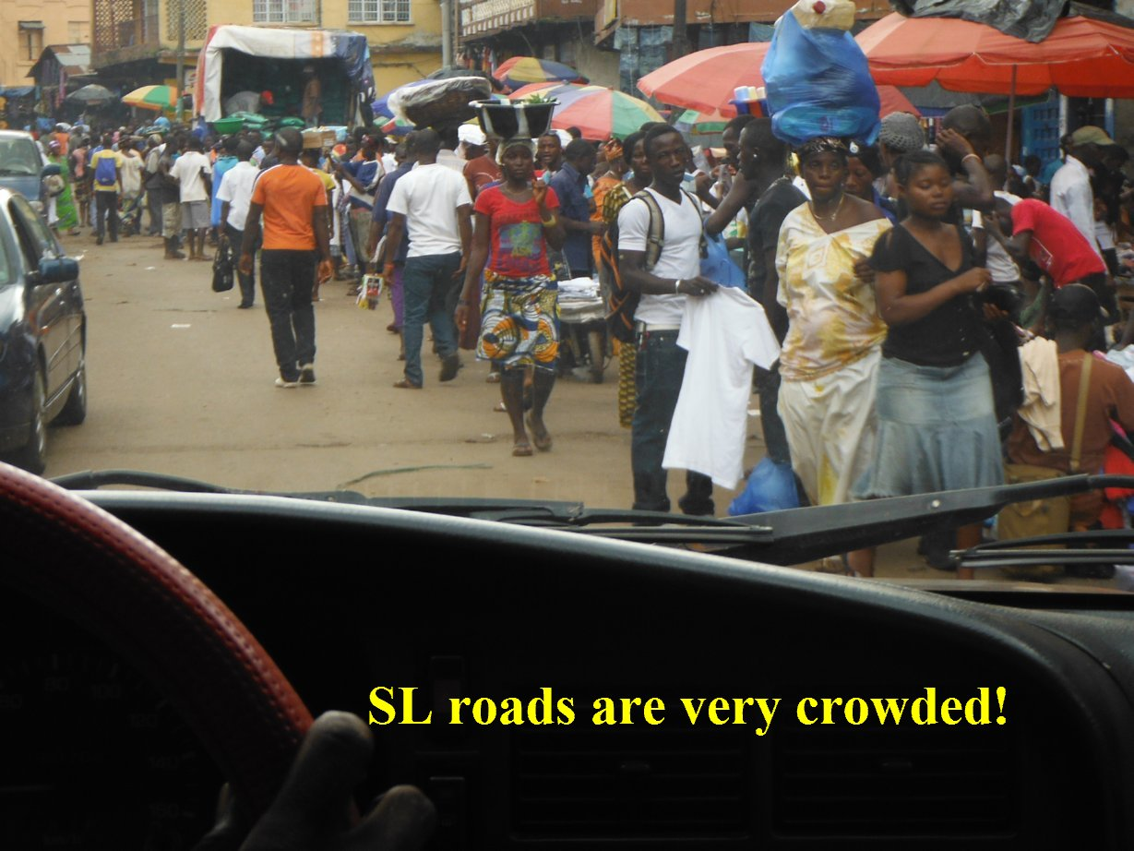

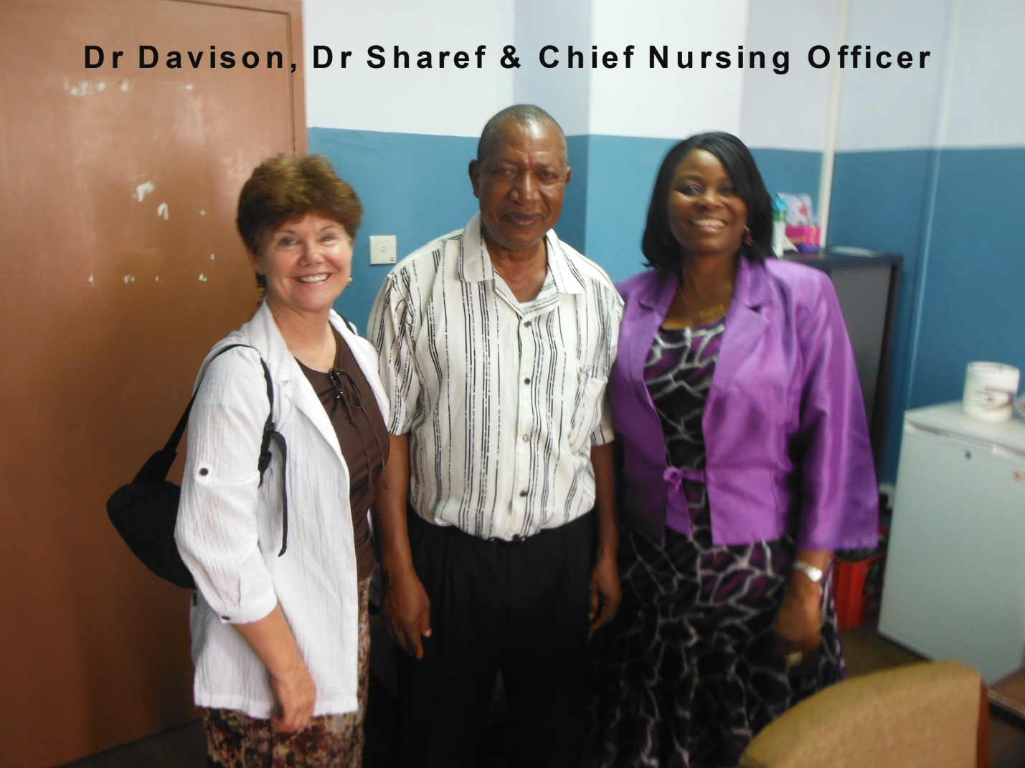
We arrived the Ministry Of Health building and walked up to the 5th floor. The elevators are not functional. After waiting for two hours, we were able to speak with the Chief Nursing Officer. She was very kind, helpful and encouraged us to try to meet with the Dean of the main school of nursing in Freetown and the State sponsored hospital PMCH. She and other nurses we spoke to while we were waiting said that the level of nursing was as follows:
- Community nurse (not RN)
- 2 -3 years of nursing curriculum to become a RN (equivalent to a AD or Diploma program)
- Once an RN you can take additional training to become a midwife, nurse anesthetist, public health nurse, nurse educator
- BSN is relatively new degree, both the chief nursing officer and RNs we spoke to thought that you had to be a RN first and go an additional 4 years to get your BSN. If you were not an RN 1st the chief nursing officer thought you had to do an additional 18 months of training before sitting for RN. As I found out later from the Dean at the School of Nursing, that is not true. He was trained in England and encouraged nurses to get their BSN without the additional “18months RN training” as it is built into the curriculum. He also told me there is no nurse practitioner program but he would like to offer one and has asked to look at our plan of study. RN exams are similar to NCLEX but they use the British exam and base their training on it.

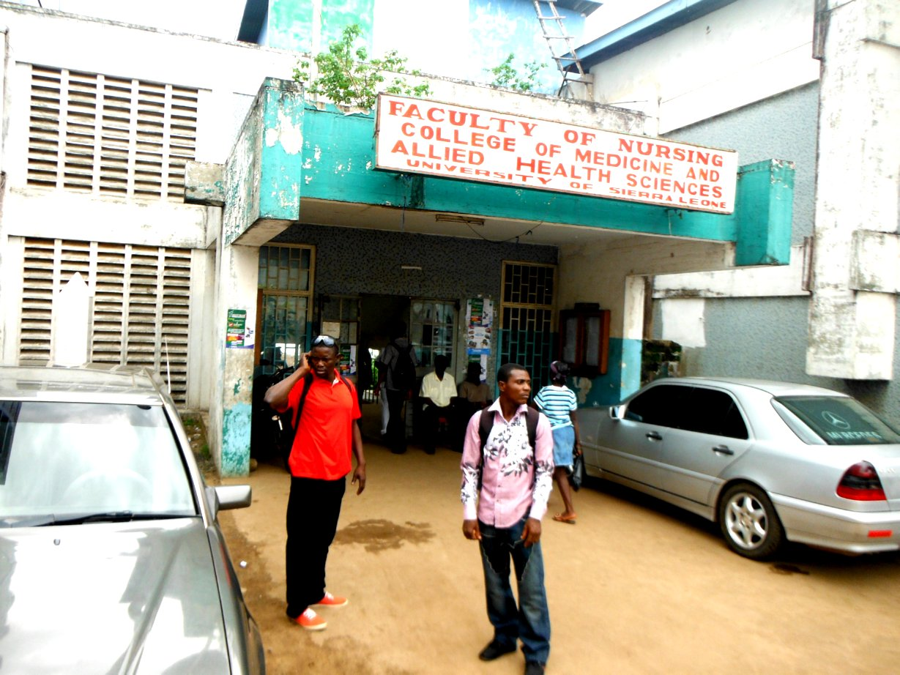

Later we were able to make arrangements for Jean to teach physical assessment classes to the nursing instructors.

Leaving the Ministry of Health we went to School of Nursing of the University of Sierra Leone, but the Dean was tied up in teaching until 5pm. We then went to the women’s and children’s hospital: PMCH. The chief nurse who also is responsible for the midwives and CRNA had left for the SON, but the chief anesthesiologist was excited that Ron was here to teach and has set up for him to do a lecture on Monday from 10:00am to noon. We will then provide lunch and he will lecture again from 1pm to 2:30. This will be for the anesthesiologists, CRNA and maybe other doctors/midwives? Prior to the 8am lecture they always review cases on Monday from 8am to 10am like ground rounds.

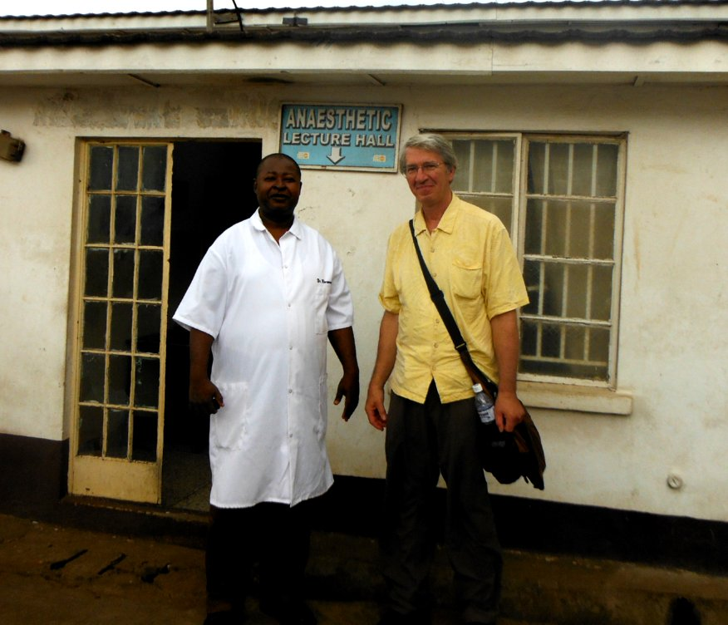

After the hospital we drove out to a building that the European Union built for a college of sciences 10 years ago. There was some problem with malpractice or political corruption and the building was never completed. Dahan has asked to use the building and with the newer elected officials it is still under negotiation. It is a wonderful building on top of a mountain just outside of the city. There is a caretaker that lives there and is trying to help Dahan, but had problems reaching him while he was in the states. Also Dahan changed phone # and his cell phone has been dead since we arrived. It may have been a blessing our plane was delayed in Liberia as we met people from World Vision and John Hopkins University. Also Dahan met someone at the airport from the European Union who told Dahan they have given the SL government as ultimatum to use the building as meant for or pay back with fees.
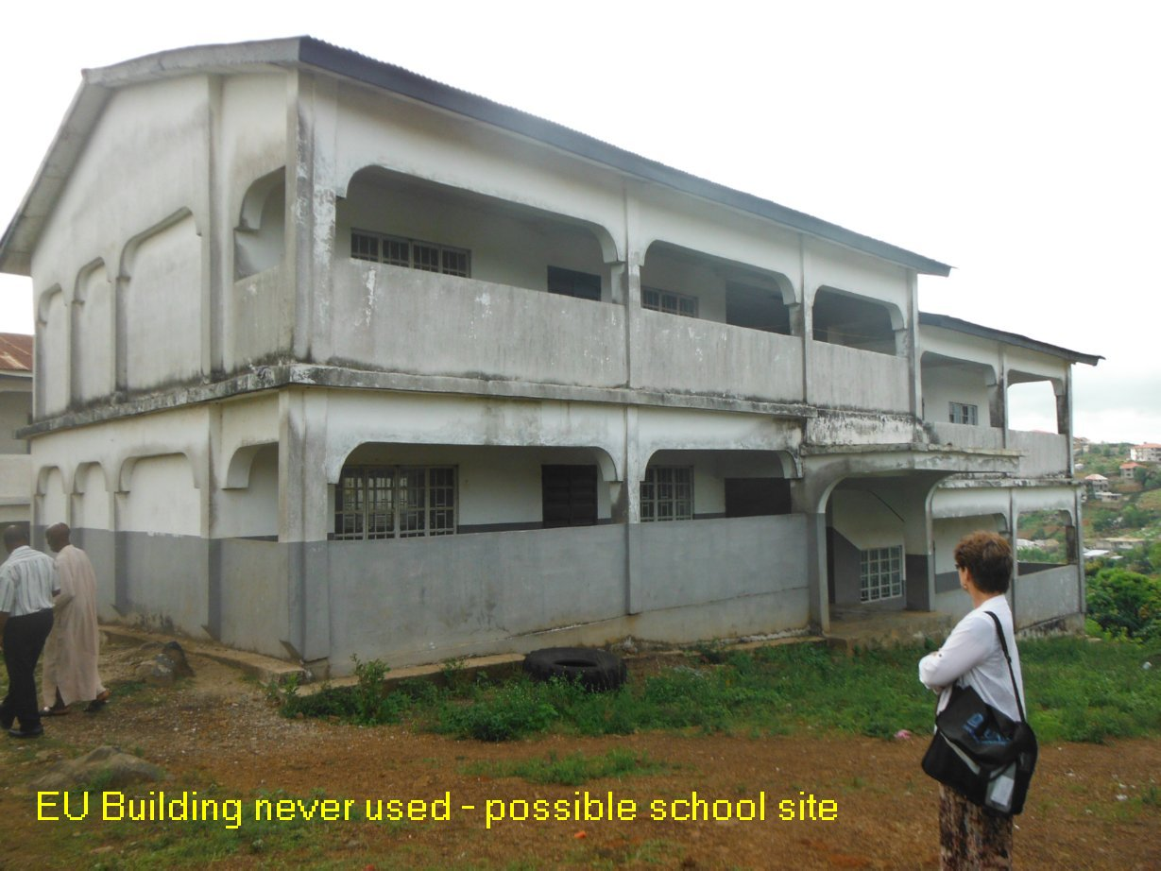

The European Union has told Sierra Leone to use this educational building as intended or pay for it.

The next day we finally met up with the Dean of the school of nursing, and as it turned out the chief of nursing from the hospital was there too.
Dr. Joseph Edem-Hotah,Dean-Faculty of Nursing
College of Medicine and Allied Health Sciences, University of Sierra Leone
Lightfoot Boston Street
Freetown
Telephone 00 232 76 879523/00232 33 131289 jedemhotah@yahoo.com
He is also the Directorate of Postgraduate Training, Non-communicable diseases and research, Ministry of Health and Sanitation
Connaught hospital
Wallace Johnson Street, Freetown
He was extremely friendly, encouraging and hopes to set aside time for me to do some of the physical assessment lectures on Thursday, maybe with BSN students 9am to 1pm.
The chief nurse from the hospital would also like Ron and I to present to midwives maybe on Friday.
We are also planning on doing the chapel presentation on Science and Religion Friday morning at 8am.
Wednesday: we confirmed our teaching schedule and got our supplies together for handouts, projector etc. Our itinerary is as follows:
Thursday 9am until done Jean will teach physical assessment skills at the School of Nursing
Friday 8am-9am worship at Grace Chapel
10am at PCMH Hospital with chief nurse- class for midwives (Jean and Ron)
Monday 10am after grand rounds Ron will do one lecture at 10am, then lunch and another lecture after lunch.
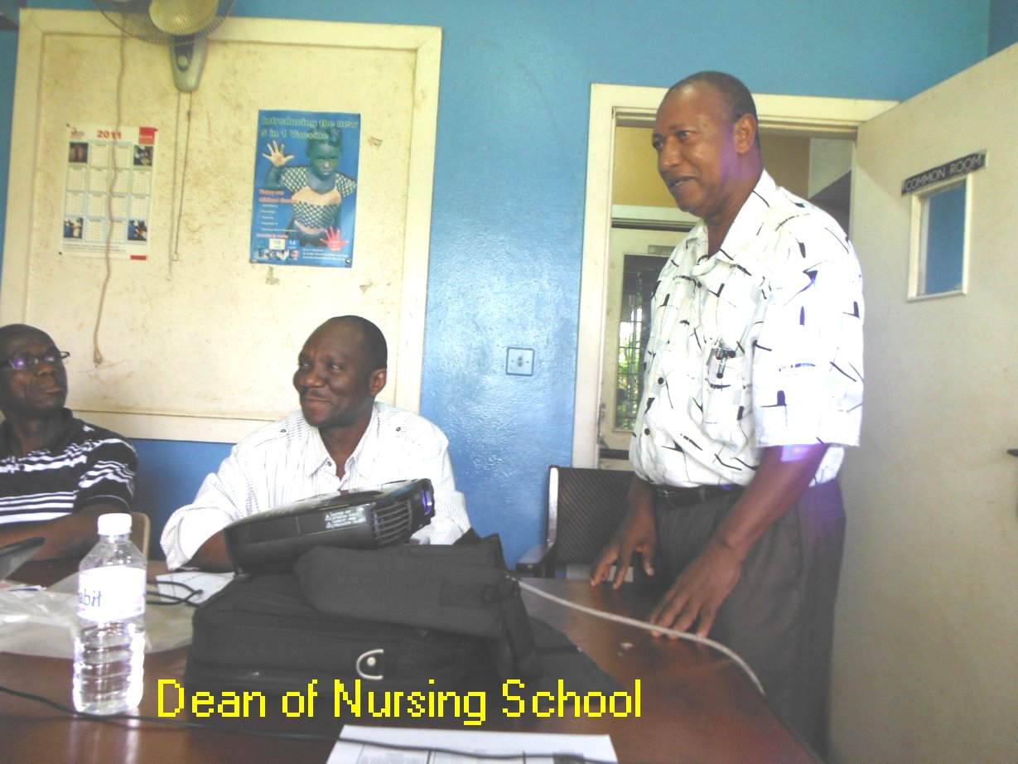
Visual Highlights

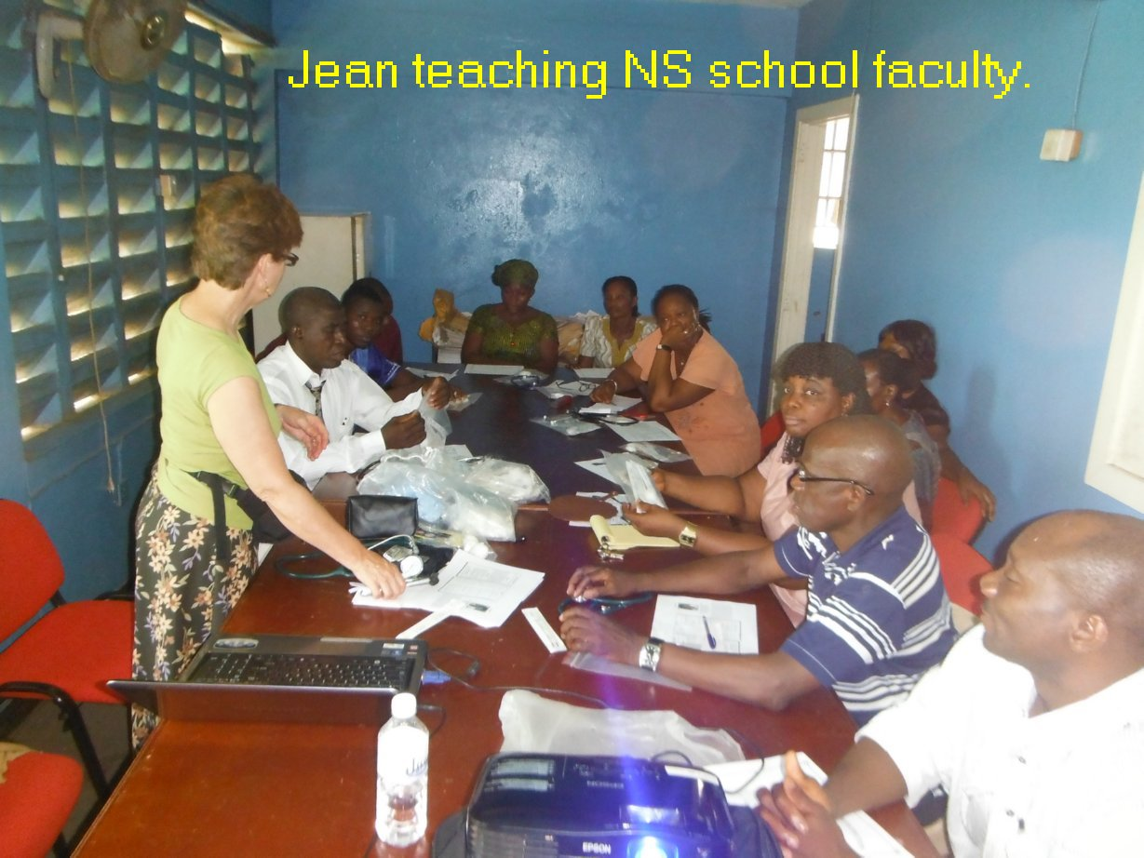

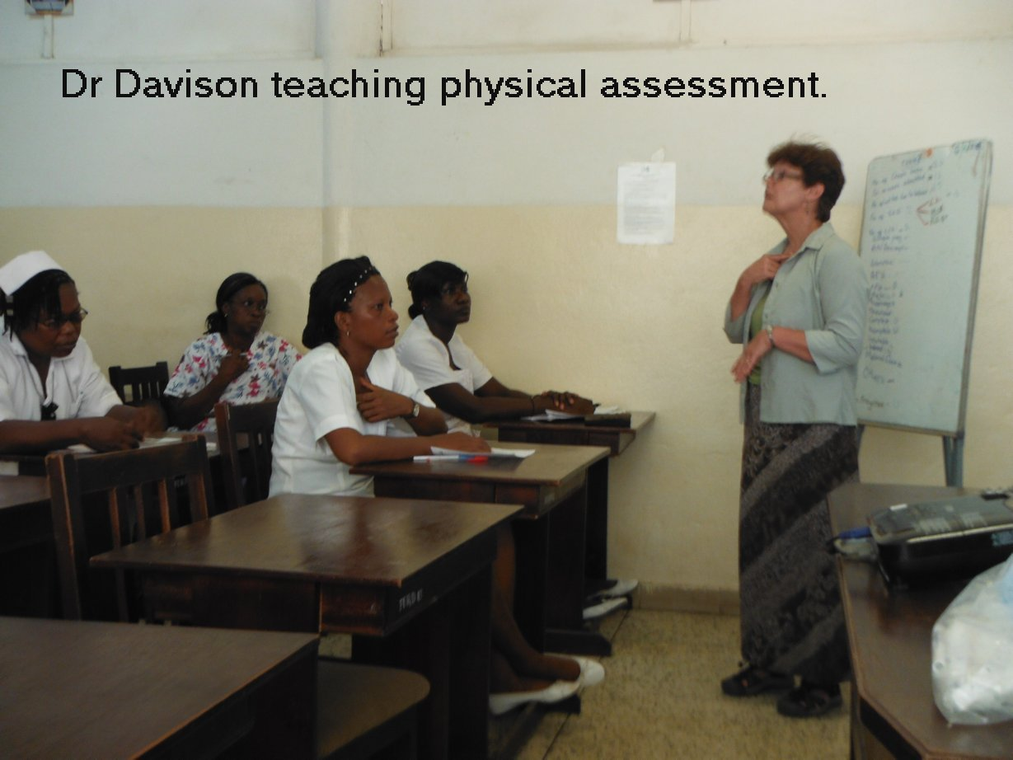

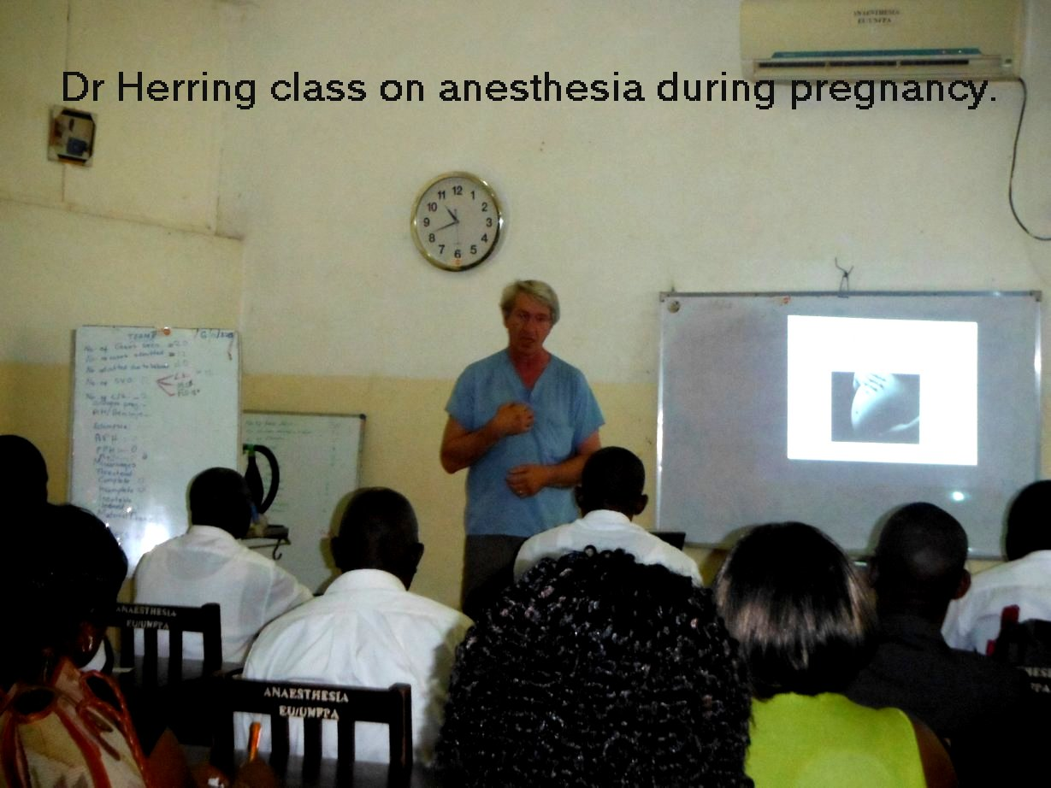
The anesthesia lectures were well attended by nurse midwives, medical students and nurse anesthetists.

One of our goals was to visit the sites proposed for a new school of nursing. One of the sites was the empty EU building in Sierra Leone which we profiled in an above picture. Dr Sharef also owns some land about 30 miles outside of Freetown. He has had the land cleared.

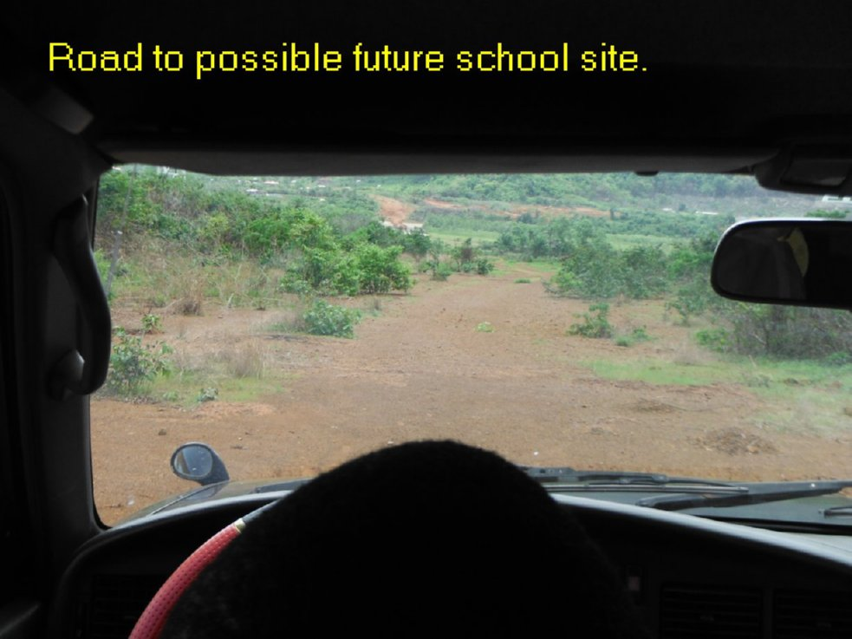
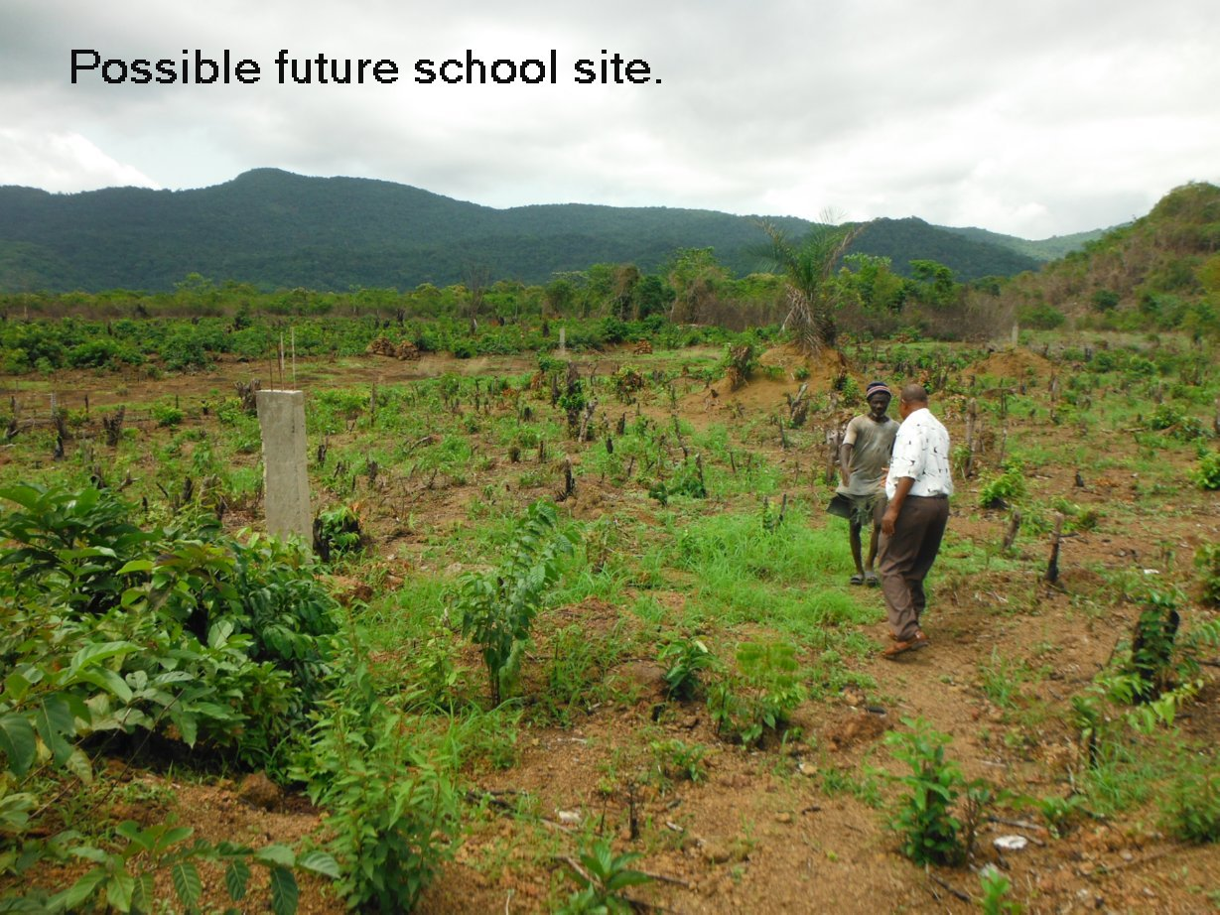
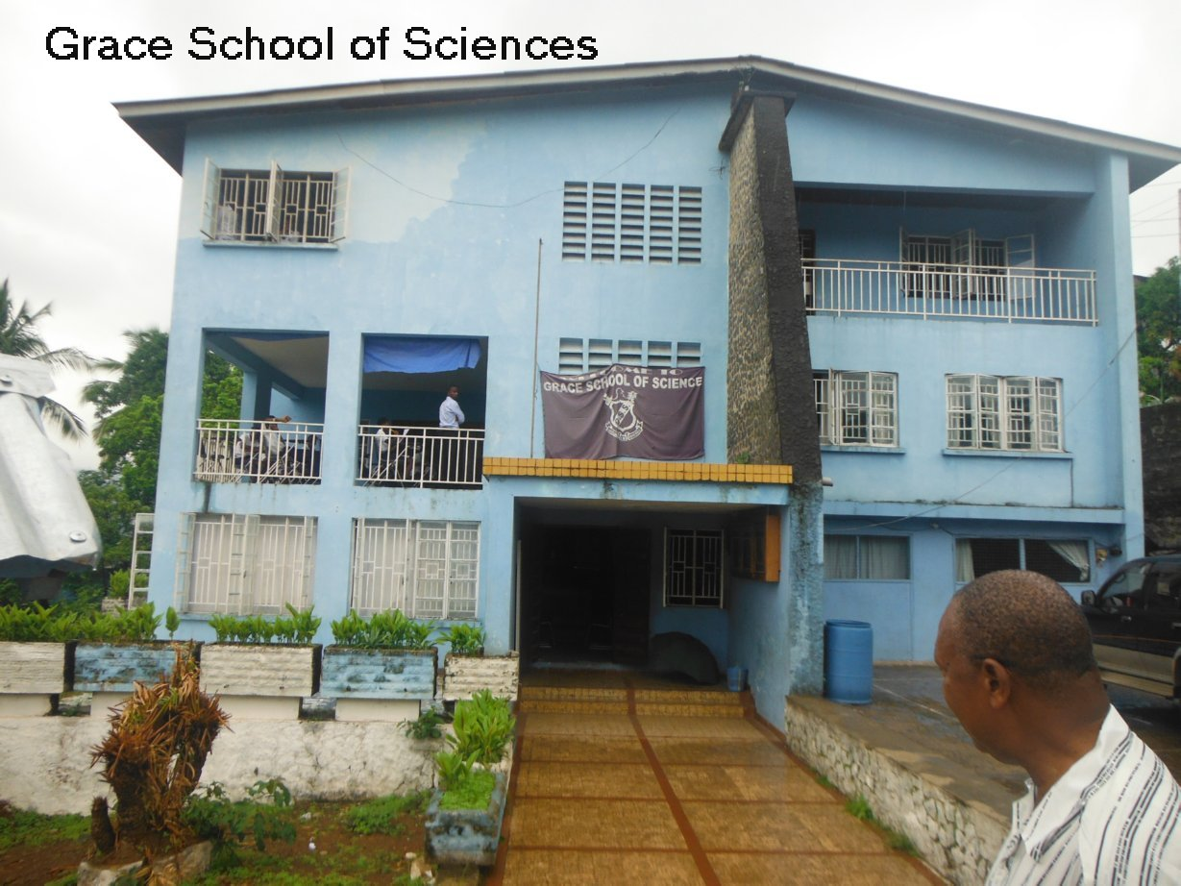

Grace School of Sciences is a remarkable success story. In just a few years it has become a premiere school of learning in Sierra Leone. It has a graduation and successful completion rate of national exams of over 98%. Christian worship is held in the building once a week. Although the attendance is not mandatory, it is usually overflowing. We both had the wonderful opportunity to speak to the students during a service and it was quite a blessing.

Summary:
There is no question that Sierra Leone has a serious need for competent nurses. However, the best path for upgrading and expanding nursing care in Sierra Leone is a complex issue. There are very significant logistical and governmental barriers to establishing an entirely new nursing school. Those barriers are so high that we deem the success of such an effort in the near term to be very unlikely. However, we have concluded that it would be possible to offer current registered nurses (RNs) a pathway to a BSN. Such a pathway could be mostly online with perhaps one day a week traditional classes in the evening. It might be possible to use the Grace School of Sciences as a resource in such a program.

